http://carsguru.net/f/pdd/pdd/1_11_1-1_11_2.jpgСхема автополигона ТФ ГБОУ СПО БКТ и С

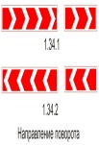

http://carsguru.net/f/pdd/pdd/1_3_1.jpg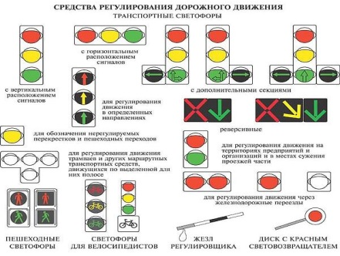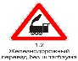

въезд

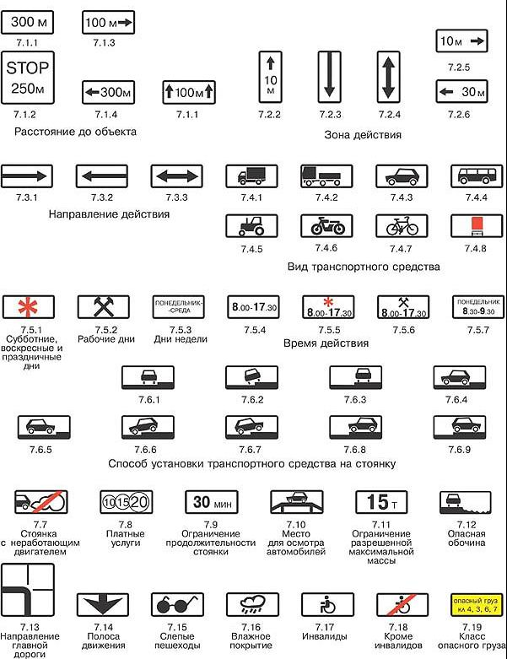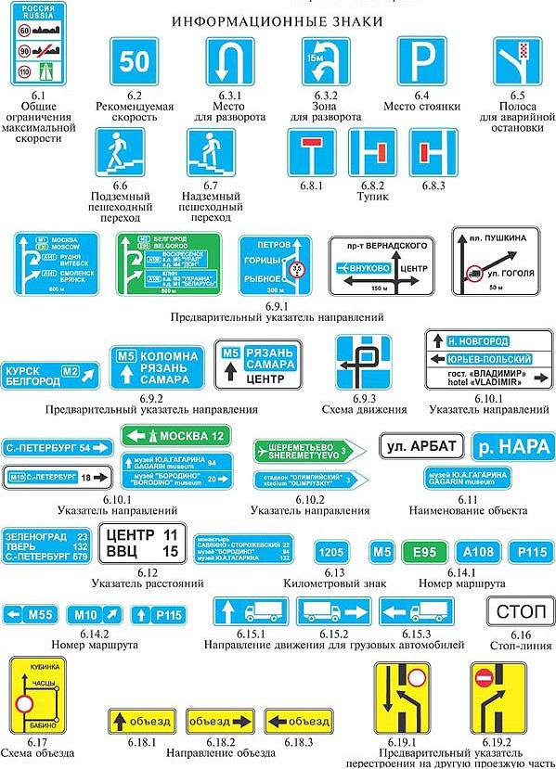http://carsguru.net/f/pdd/pdd/2_4.jpghttp://carsguru.net/f/pdd/pdd/1_3_1.jpg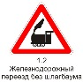http://nevaznak.com/media/images/bd72d7bb33d0b0c108555b08151320d5.jpeg

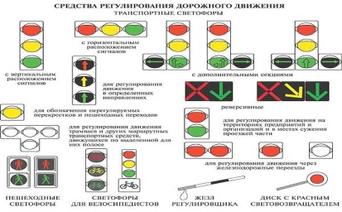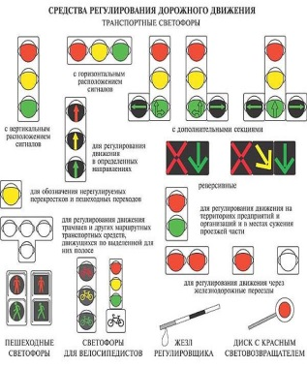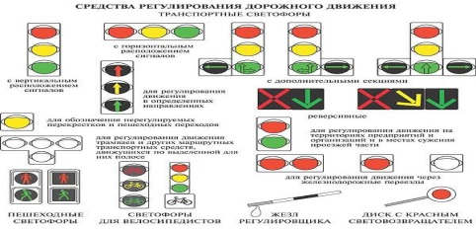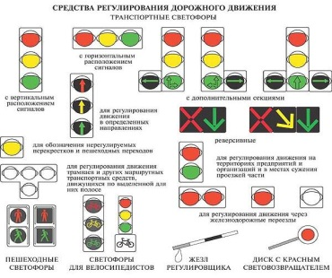http://carsguru.net/f/pdd/pdd/2_5.jpghttp://carsguru.net/f/pdd/pdd/2_2.jpghttp://carsguru.net/f/pdd/pdd/2_2.jpghttp://carsguru.net/f/pdd/pdd/2_1.jpg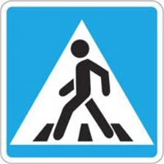

http://carsguru.net/f/pdd/pdd/2_4.jpghttp://carsguru.net/f/pdd/pdd/2_1.jpg

http://carsguru.net/f/pdd/pdd/2_5.jpg